2. Extended Entity Relationship Model
An Extended Entity-Relationship Diagram (EERD) is an advanced version of the traditional Entity-Relationship Diagram (ERD) used in database design. EERDs include additional concepts and features to model more complex relationships and constraints in a database schema. Here are some key elements and notations commonly used in an Extended Entity-Relationship Diagram:
- Entities: Entities represent real-world objects or concepts. They are typically depicted as rectangles with the entity name inside.
- Attributes: Attributes describe the properties or characteristics of entities. They are shown as ovals connected to their respective entities by lines. Each attribute has a name and a data type.
- Key Attributes: Key attributes uniquely identify each entity within its set. They are underlined or marked with a key symbol.
- Derived Attributes: Derived attributes are attributes whose values can be calculated from other attributes in the database. They are represented with a dashed oval.
- Relationships: Relationships describe how entities are related to each other. They are represented as diamond shapes connecting the related entities. The cardinality and participation constraints of relationships can be indicated near the diamonds.
- Cardinality Constraints: These constraints specify the number of instances of one entity that can be related to the other entity. Common notations are "1" (one) and "M" (many).
- Participation Constraints: These constraints specify whether the participation of entities in a relationship is mandatory (total) or optional (partial).
- Roles: In some cases, the same entity can participate in multiple roles within a single relationship. Roles help clarify the purpose of an entity within a specific relationship.
- Multivalued Attributes: Multivalued attributes are attributes that can have multiple values for a single entity. They are represented with a double oval.
- Weak Entities: Weak entities are entities that do not have a primary key attribute on their own. They rely on a relationship with a strong entity (called the identifying or owning entity) for identification.
- Specialization and Generalization: EERDs allow for the modeling of hierarchical relationships between entities through specialization and generalization. An entity can be specialized into subtypes, and generalization represents a higher-level entity that encompasses multiple subtypes.
- Union Types: Union types are used to represent an entity that can be one of several entity types. It is typically depicted as a circle with labeled arcs pointing to the possible entity types.
- Aggregation: Aggregation represents a higher-level entity composed of related entities. It is depicted as a diamond shape with a line connecting it to the aggregated entities.
- Constraints: Constraints can be added to specify additional rules and requirements for the database schema, such as uniqueness constraints, referential integrity constraints, or check constraints.
Extended Entity-Relationship Diagrams are particularly useful for designing complex databases with intricate relationships and constraints. They provide a more comprehensive and structured way to model data compared to traditional ERDs, making them valuable tools in database design and development.
Mapping the EER diagram to Relational table
The relational model represents how data is stored in Relational Databases. A relational database consists of a collection of tables, each of which is assigned a unique name. The relational model can represent a table with columns and rows. Each row is known as a tuple and each table of the column has a name or attribute.
Properties of Relation:
- The name of the relation is distinct from all other relations.
- Each relation cell contains exactly one atomic (single) value
- Each attribute contains a distinct name
- The attribute domain has no significance
- Tuple has no duplicate value
- The order of tuples can have a different sequence
A database is an organized collection of structured information, or data, typically stored electronically in a computer system. A database is usually controlled by a database management system (DBMS). Together, the data and the DBMS, along with the applications that are associated with them, are referred to as a database system, often shortened to just a database.
Data within the most common types of databases in operation today is typically modeled in rows and columns in a series of tables to make processing and data querying efficient. The data can then be easily accessed, managed, modified, updated, controlled, and organized. Most databases use structured query language (SQL) for writing and querying data.

Restaurant
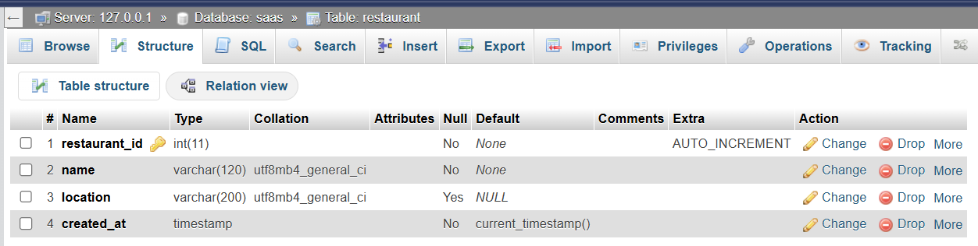
Customer
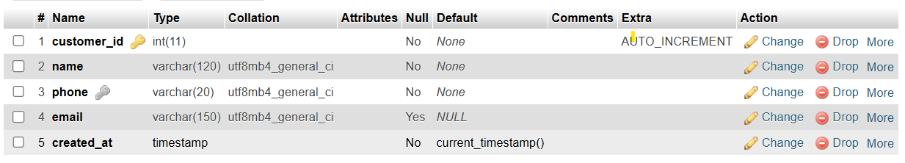
Wallet
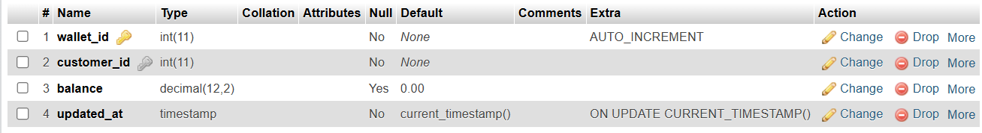
Menu Item
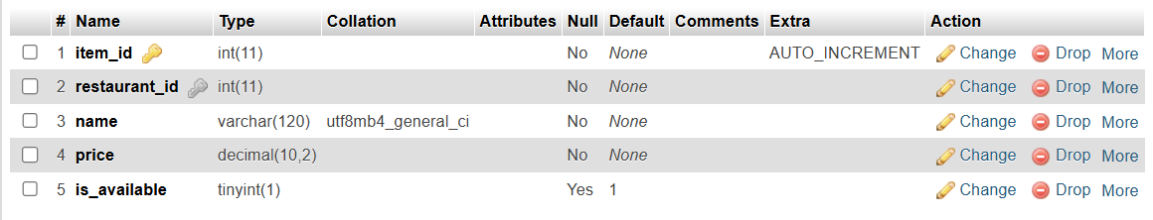
Orders
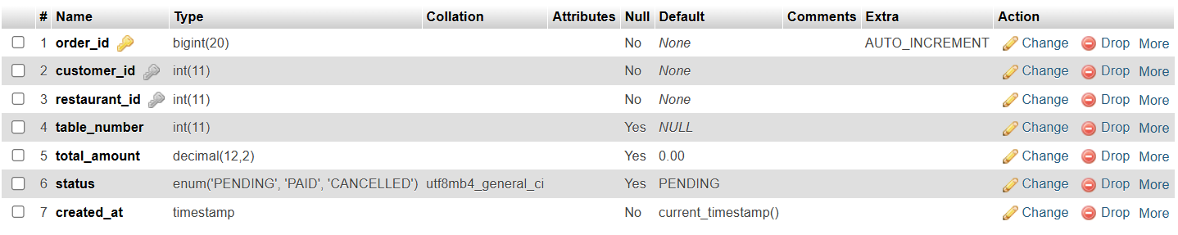
Order Item
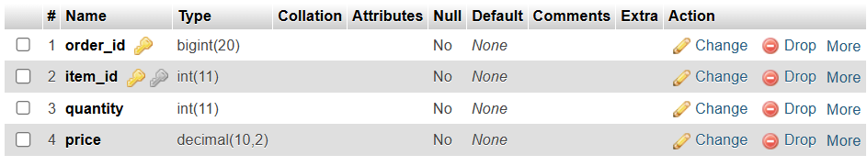
Wallet Transaction
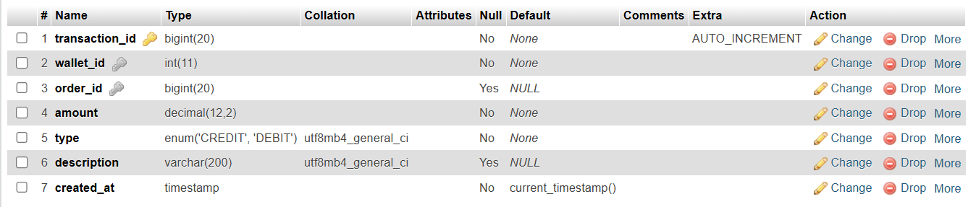
Relation Model of SAAS Application:
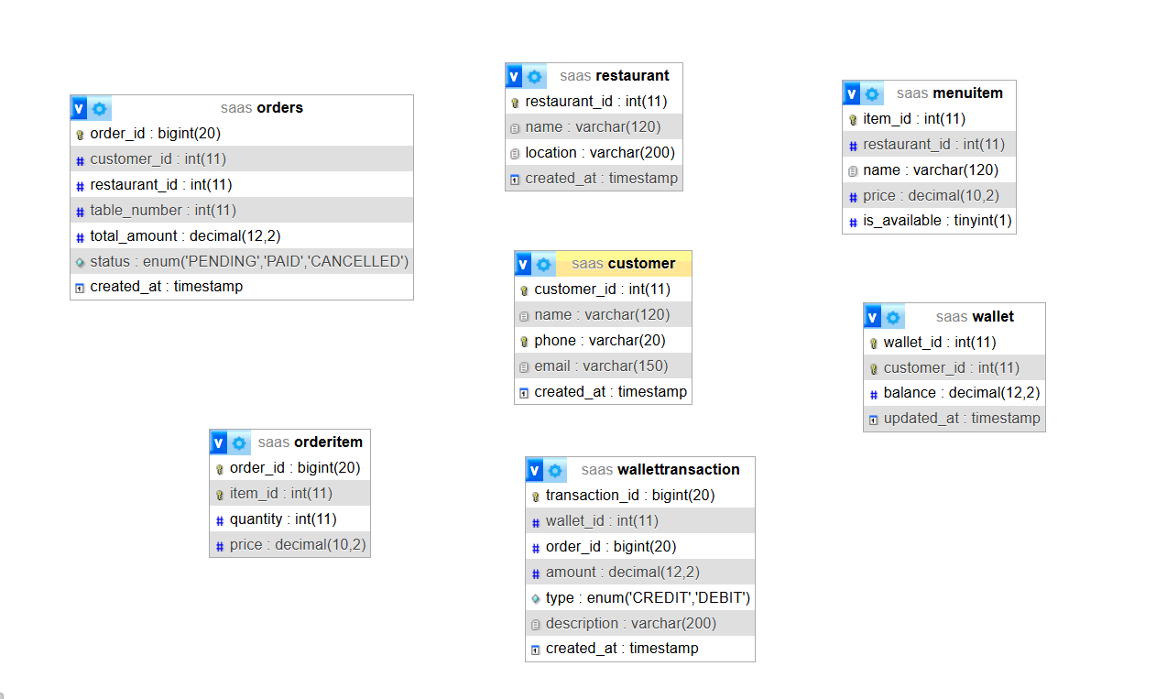
Figure 2: Designer Relationship of Saas application
SQL commands in Relational Databases with stored procedure and Triggers:
Create table wallet transition:
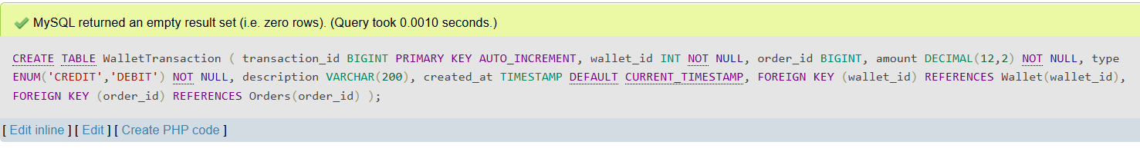
Insert multiple data into database:
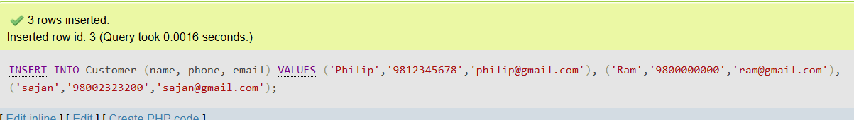
Drop the table:
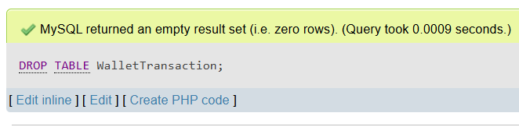
To update data:
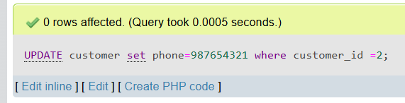
To delete records:
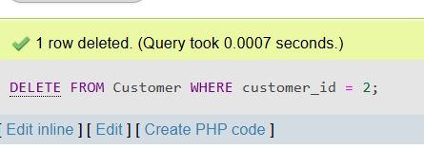
To alter the table:
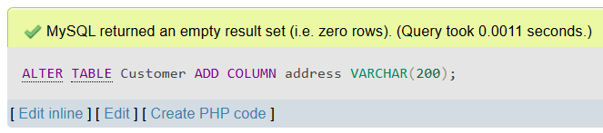
Join:
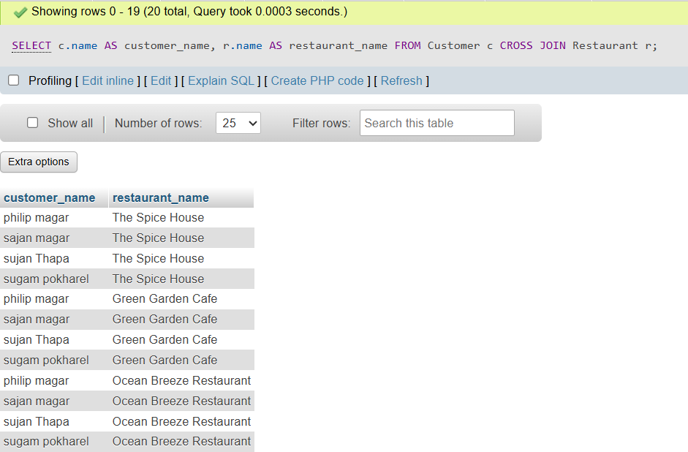
Inner join:
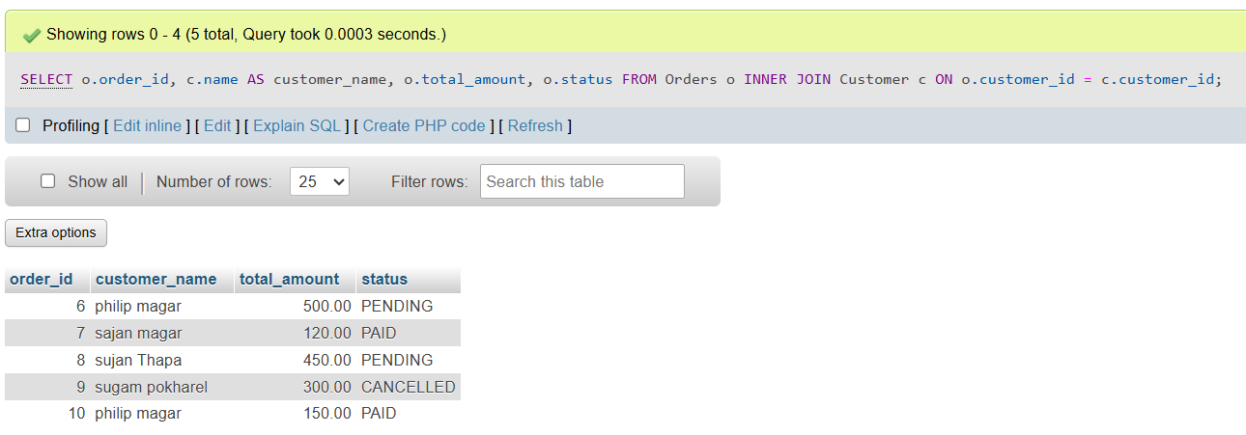
Left join:
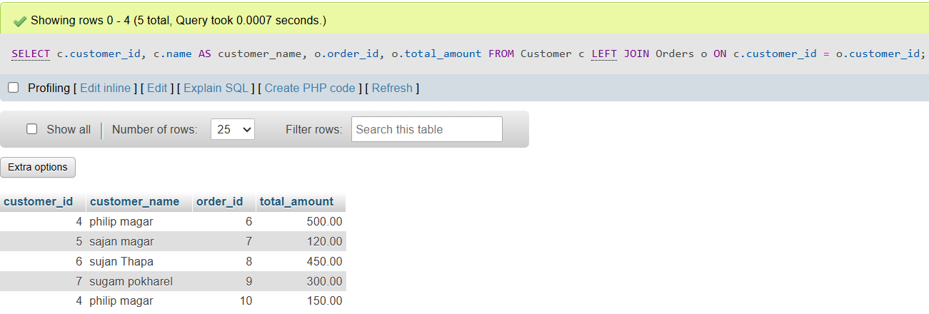
Right join
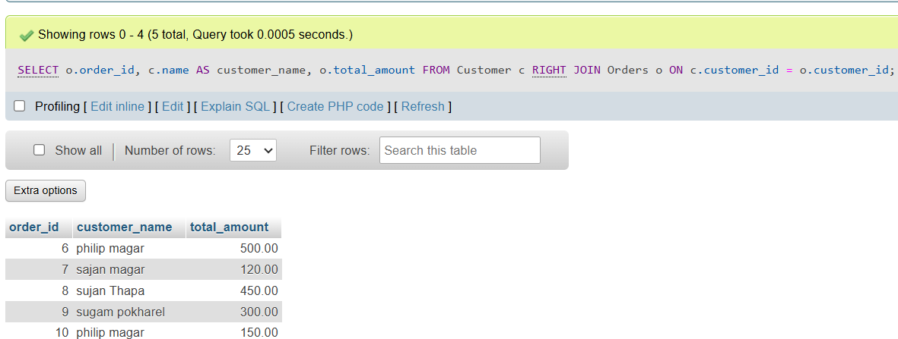
View:
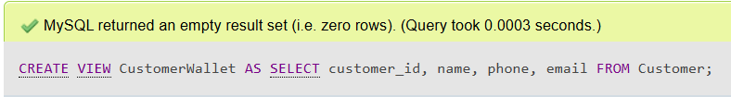
Selecting data from view:
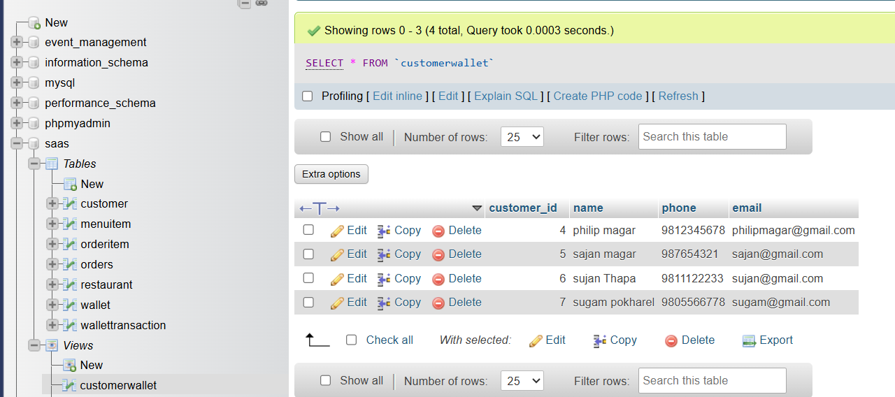
Creating procedure:
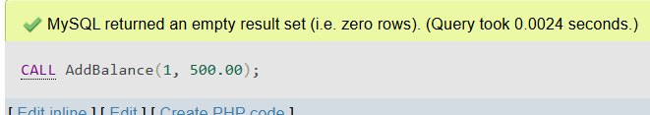
Creating trigger:
DELIMITER $$
CREATE TRIGGER after_customer_insert
AFTER INSERT ON Customer
FOR EACH ROW
BEGIN
INSERT INTO Wallet (customer_id, balance)
VALUES (NEW.customer_id, 0);
END $$
DELIMITER ;
Inserting data after creating trigger:
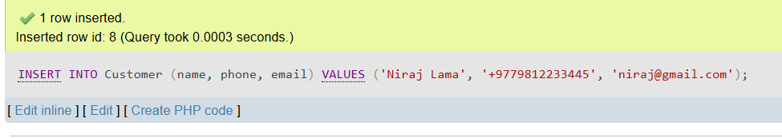
Selecting data from customer:
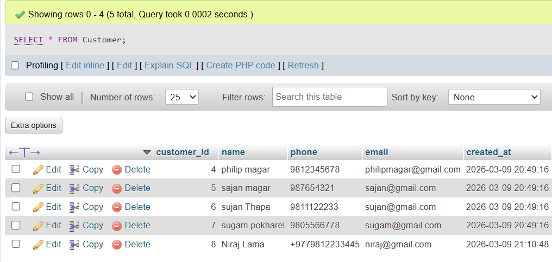
Subquery with exists:
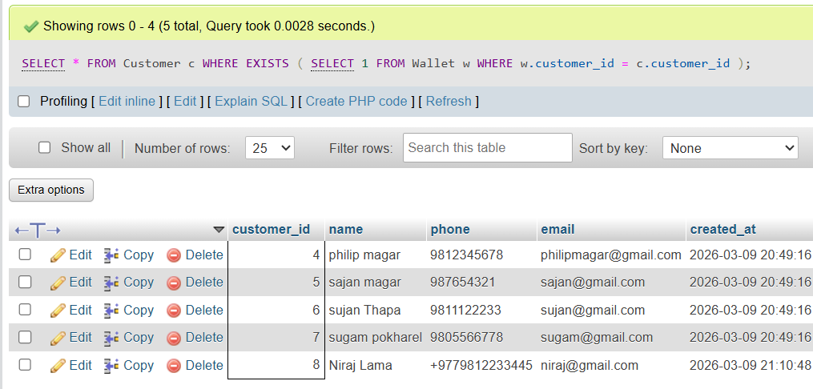
Subquery with Not exists:
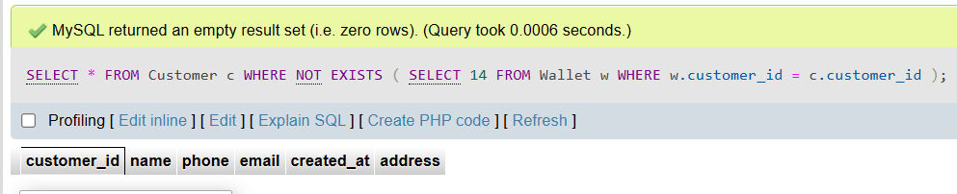
Introduction to MongoDB
MongoDB is a popular, open-source NoSQL database that is designed for flexibility, scalability, and ease of development. It belongs to the document-oriented database category and is known for its ability to handle unstructured or semi-structured data. Here's an overview of key concepts and features related to MongoDB:
- Document-Oriented Database: MongoDB stores data in a format called BSON (Binary JSON), which is a binary representation of JSON-like documents. Each document can have a different structure, making MongoDB flexible for accommodating data of varying shapes.
- Collections: MongoDB organizes data into collections, which are similar to tables in relational databases. Collections can contain multiple documents, and documents within a collection do not need to have the same fields.
- Documents: A document is a single record in MongoDB, represented as a JSON-like object. Documents can contain nested subdocuments and arrays.
- Fields: Fields are key-value pairs within a document. Field names are case-sensitive.
- ObjectId: MongoDB automatically assigns a unique ObjectId to each document as its primary key. This field is typically named _id.
- Indexes: MongoDB supports indexing for efficient querying. Indexes can be created on single fields, compound fields, or arrays to improve query performance.
- Query Language: MongoDB uses a powerful query language for searching and filtering documents. Queries can use a wide range of operators, including equality, comparison, and logical operators.
- Aggregation Framework: MongoDB provides a flexible aggregation framework for performing complex data transformations, grouping, and computation operations on data.
- Replication: MongoDB supports replica sets, which are clusters of MongoDB servers that maintain the same data for redundancy and high availability. Replica sets provide automatic failover and data redundancy.
- Sharding: MongoDB can horizontally scale by using sharding. Sharding divides data across multiple servers based on a shard key, allowing for distribution of data and queries.
- Transactions: Starting with MongoDB 4.0, MongoDB supports multi-document transactions, making it suitable for applications requiring ACID (Atomicity, Consistency, Isolation, Durability) transactions.
- Geospatial Data: MongoDB has built-in support for geospatial data and geospatial indexing, allowing for location-based queries.
- Security: MongoDB offers various security features, including authentication, authorization, and encryption. Role-based access control (RBAC) can be used to manage user permissions.

Installation of MongoDB
To install MongoDB on a Windows operating system, follow these step-by-step instructions:
Step 1: Download MongoDB
- Visit the official MongoDB website at https://www.mongodb.com/try/download/community.
- Scroll down to the "Community Server" section, where you can download the MongoDB software for free.
- Under the "Windows" subsection, locate and click on the "Download" button to initiate the download of the latest stable version of MongoDB for Windows.
Step 2: Run the Installer
- After the download is complete, locate the downloaded installer file, typically found in the computer's "Downloads" folder.
- Double-click on the installer file to execute it and begin the installation process.
Step 3: Choose Setup Type
- The MongoDB Setup Wizard will appear on the screen. Click the "Next" button to proceed.
- Select the "Complete" setup type, which includes both the MongoDB server and associated tools. Click "Next" to continue.

